NAME : Sharatha sree R COURSE : Mobile Computing
Reg No : 192421033 COURSE CODE: ITA0301

29.Create wireframes for a collaborative mobile app using Figma, showcasing the peer-to-
peer interactions in real-time.

Aim:
Wireframes for a collaborative mobile app,showcasing the peer-to-peer interactions in real-
time using figma

Procedure:

- Open Figma
- Create a new file
- Select the Frames
- Design Visual Elements
- Make it Interactive
- Add icons on the Frame
- Incorporate Multimedia
- Storyboard Animation
- Review and edit the Prototype
- Save and Share

Design:
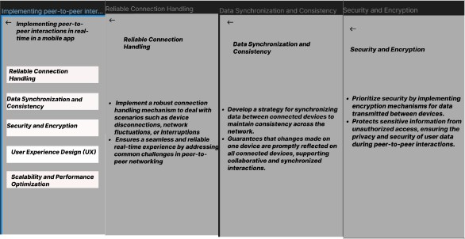

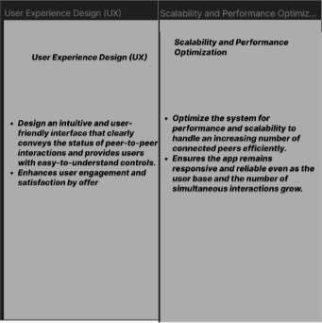

Prototype:

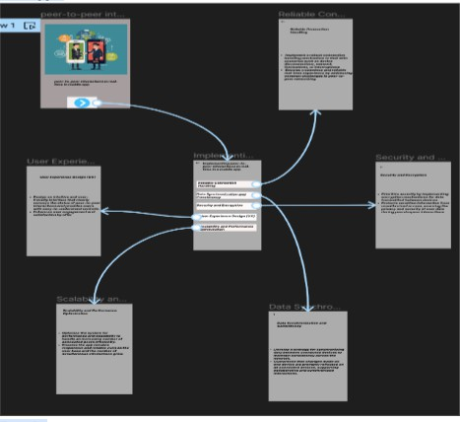

Result:

HenceWireframes for a collaborative mobile app,showcasing the peer-to-peer interactions in
real-time using figma have been created successfully

